**Module 1 Challenge Report**

**Q1: Given the provided data, what are three conclusions that we can draw about crowdfunding campaigns?**

A: Based on the pivot tables and charts created from the dataset provided, the most interesting three conclusions that may be drawn are: (1) entertaining channels could be better means to raise funds, as shown in the “Category statistics”, 187 out of 565 successful cases contributed to “theatre category”; (2) More specifically, “plays” appear to be the most effective way to raise funds, as shown in the chart from the “SubcategoryStats”; (3) It appears that timing, in particular when to launch the campaigns, does have effects on the outcomes. More specifically, the projects that were launched around the financial year end could be more likely to succeed; perhaps either due to the clearer picture of budget spending close to the financial year end or more fund seemingly available at the start of the new financial year.

**Q2: What are some limitations of this dataset?**

A: Some limitations of this dataset are likely to influence the above conclusions. For example, the sample is small, especially given the small sample covers different countries. Also, the dataset does not provide other factors that may impact on the outcomes of the campaign, such as the reasons for the campaign.

**Q3: What are some other possible tables and/or graphs that we could create, and what additional value would they provide?**

A: Some other possible tables and/or graphs that may shed more light on the analyses, based on the current dataset, could be, for example, (1) a table in which the “percentage funded” replaces the “outcomes”, given currently the “successful” is defined as “meeting or beating” the “goals”. (2) a table that includes the length of the campaign (calculated using “deadline” and “launchdate” to see if the failure of some projects may be due to the shorter frame of the campaign. (3) any tables that information users may be interested in, for example, using the “average donations” instead of the “outcomes” or “percentage funded”.

**Bonus Questions**

**Q1: Use your data to determine whether the mean or the median better summarises the data.**

A: From “BonusdataStats” and the box and whisker charts below, the data appear to be seriously right skewed. Therefore, the mean perhaps better summarises the data.



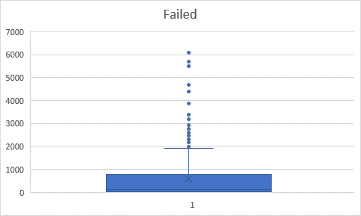

1. Use your data to determine if there is more variability with successful or unsuccessful campaigns. Does this make sense? Why or why not?

A: As shown in the “BonusStats” in the excel file, the variance (standard deviation) for successful campaigns are 1606217 (1267) while the variance (standard deviation) for unsuccessful campaigns are 924113 (961), which indicates that there is more variability with successful campaigns than with unsuccessful campaigns. This makes sense because both the amounts and range for unsuccessful campaigns are much smaller.